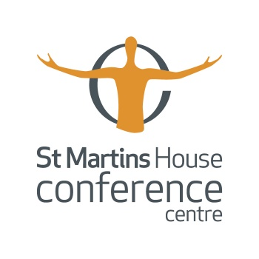

Meetings and events with safe, social distancing at St Martins House

At St Martins House Conference Centre, we have set out some guidelines when running your events to keep everyone safe. These guidelines detail the specific measures that we are taking to ensure that meetings and events resume once more. Given the ever-changing nature of this situation this plan will also keep changing and evolving to ensure it remains up to date, relevant and effective.

It will mean we have to do things differently and some of our usual standards and levels of hospitality will temporarily be amended, but rest assured we will still be putting you first, doing whatever we can to make your time with us as enjoyable as is possible but all focussed on keeping you, along with our hard working and extremely dedicated team members safe.

- The room capacities of all the rooms will be changed to allow for social distancing of two metres between people.

  - Cabaret layout now has 3 delegates per table
  - Theatre layout gives 2m space between chairs
  - Boardroom layout now means each delegate has their own desk

- A ‘one-way’ system for clients to move around once in the building will be in operation so that close delegate proximity is minimised.

- Registration for events will have to be carried out prior to arrival at St Martins House so that delegates are ticked off on a list by the organiser as they enter the building to avoid queuing.

- For access to The Grand Hall, the lift will be monitored so that it is only used by delegates with mobility issues.

- Similarly, the use of the ground and first floor toilets will be monitored so that queues cannot form, and the facilities provided will be modified to avoid close proximity.

- We shall cease to provide pads, pens and wrapped sweets.

- Water coolers will be provided instead of bottled water on tables.

- All catering will be served in a room separate to the room in which the event is being held. For smaller groups, this can be served in the White Rose Café which will offer exclusive use.

- The catering offer will be modified to packaged items for clients to collect (grab and go), no utensils will be used.

- Additional hand sanitizer, gloves and anti-bac wipes will be available for delegates use on touch point areas of the collection station.

- All staff will wear appropriate personal protective equipment and observe social distancing measures.

- Where possible, a one-way system will be operated whereby delegates enter the catering room through one door, file past the catering station(s) and exit through another door taking the food back into their meeting room to be consumed there.

- Clients will be advised that refreshment breaks will take longer than usual and to make sufficient time allowance in their agenda for the day.

- Clients will be advised of the ways in which technology can help them deliver their event.

- Questions and answer sessions will be conducted from fixed points within the meeting room to avoid the use of roving microphones.

- The use of lapel microphones will be discouraged in favour of fixed microphones.

- There will be hand sanitiser points throughout the building, including meeting rooms.

- Anti-bac wipes will be available in all meeting rooms.

- All tables and chairs in meeting rooms will be sanitized after reset.

- All furniture and equipment will be sanitized after reset, including:

  - Phones and remotes
  - Thermostats
  - Cabinetry, pulls and hardware
  - Doors and doorknobs
  - AV accessories
  - Windows, mirrors and frames

- There will be a constant cleaning presence throughout the day.

Responsible Delegates
We will rely on all our delegates, guests and team members to do their bit in ensuring the safety of all. As such delegates will be given prior to and on arrival written instructions on respecting physical distancing protocols in the meeting room and social areas, including refreshment break areas.

Meeting organisers will be asked to outline protocols for entering/leaving meeting rooms, congregating at breaks and meals times, at the beginning of the meeting.

Delegates will be asked to remain in allocated seats, for the duration of the meeting/event.

